EXPERIMENT – 15
Perform Basic Image Handling and Processing Operations: Read an Image in Python and Detect Corners Using Harris Corner Detection
Aim
To read an image using Python and OpenCV and detect corners using the Harris Corner Detection function.
Procedure
- Import the OpenCV and NumPy libraries.
- Read the input image using cv2.imread().
- Check whether the image is loaded successfully.
- Convert the image into grayscale using cv2.cvtColor().
- Convert the grayscale image to floating-point format.
- Apply Harris Corner Detection using cv2.cornerHarris().
- Dilate the corner response to highlight detected corners.
- Mark the detected corners on the original image.
- Display the original and corner-detected images.
Program
import cv2
import numpy as np

image = cv2.imread("image.jpg")

if image is None:
print("Image not found!")
else:
gray = cv2.cvtColor(image, cv2.COLOR_BGR2GRAY)
gray = np.float32(gray)

corners = cv2.cornerHarris(gray, 2, 3, 0.04)
corners = cv2.dilate(corners, None)

result = image.copy()
result[corners > 0.01 * corners.max()] = [0, 0, 255]

cv2.imshow("Original Image", image)
cv2.imshow("Harris Corner Detection", result)

cv2.waitKey(0)
cv2.destroyAllWindows()
Sample Input
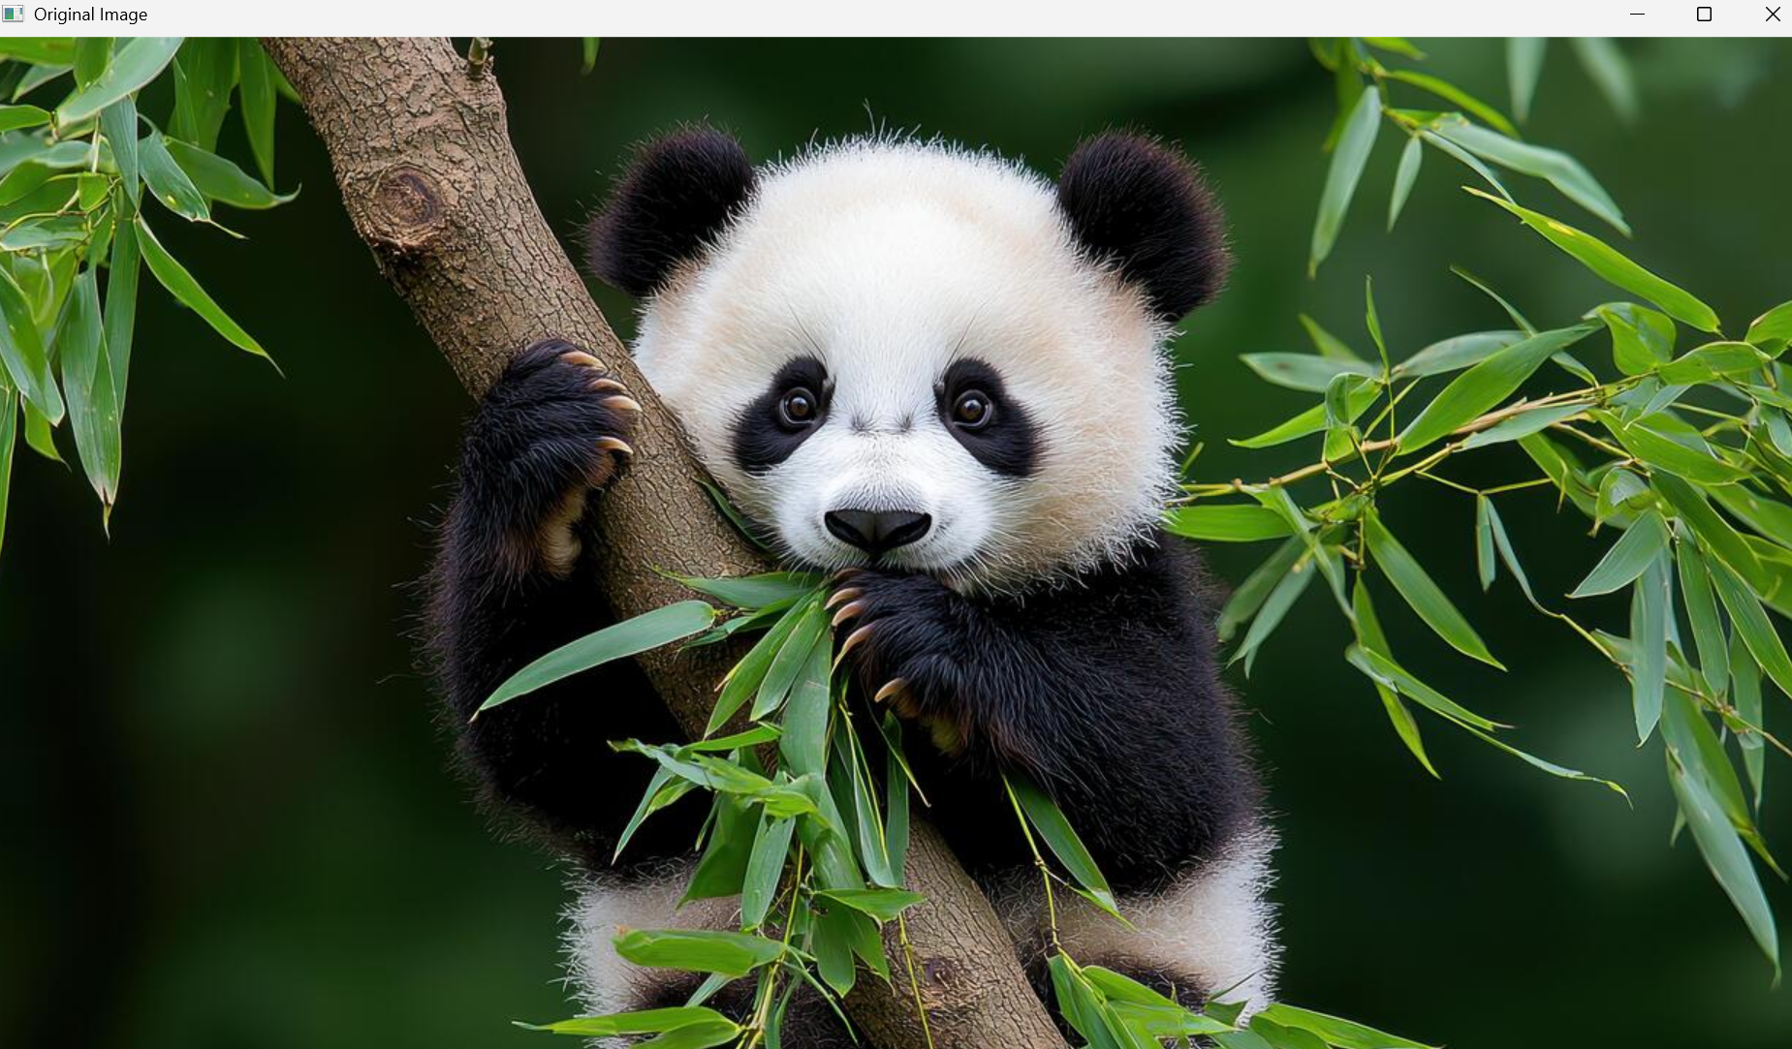
Sample Output
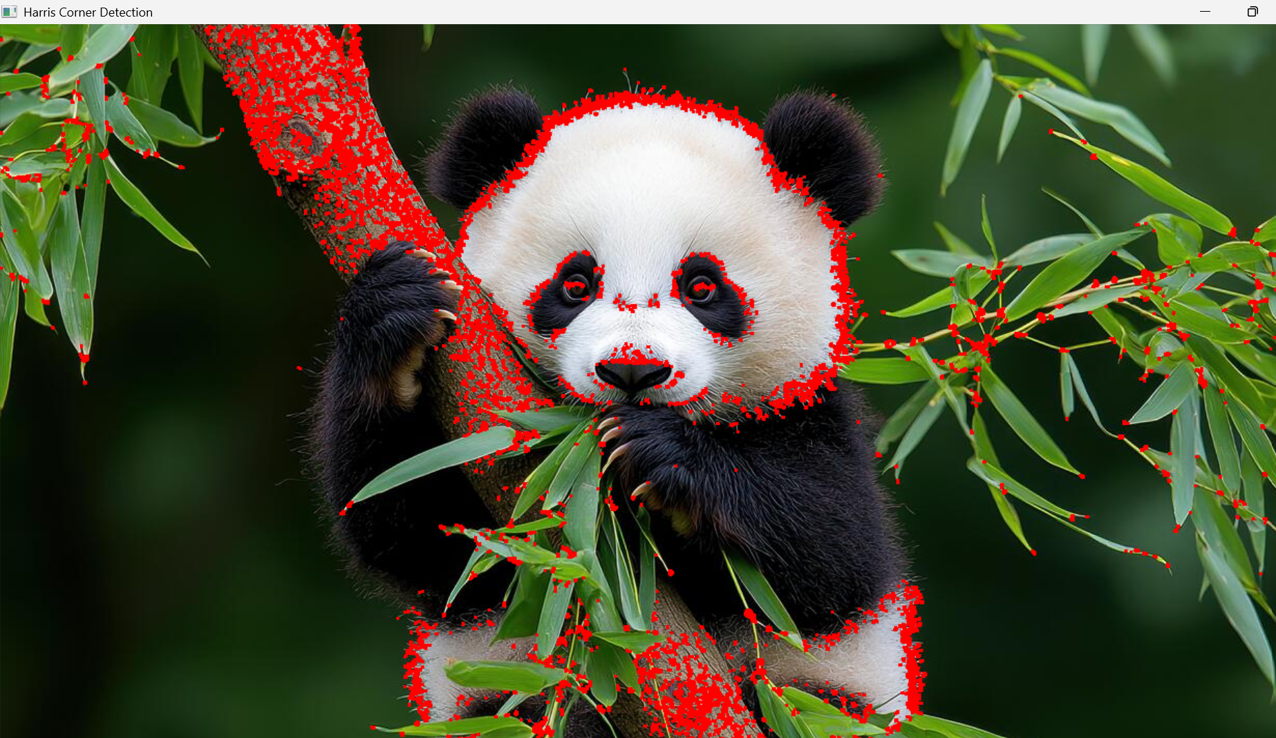
- Image with detected corners highlighted in red.
Result
Thus, Harris Corner Detection was successfully performed using Python and OpenCV to identify corner points in the image.

